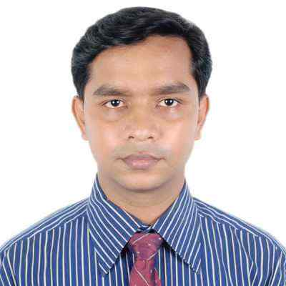
RESUME OF DEBASIS MAJUMDER
Honors, Masters in Accounting, EMBA, ITP (Income Tax Practitioner)
Nine Years Experience in Finance & Accounts
Cell: 01716 126 937, E-Mail: debactg@gmail.com
.
Objective: To achieve and secure a superior post in a friendly atmosphere like Financing sector or a multinational company by developing personal and organizational skill through multiplying experience and acquiring up to date knowledge, in related fields, which would enable me serving my society along with building my career.

Job Profile:

(Sept, 2012 – Still now) Asst. Manager (Finance & Acct.)
MH Group
Corporate Office, Khatungonj, Chittagong.

(Oct. 2009 – Sept, 2012) Senior Executive (Finance & Accounts)
Baizid Steel Industries Ltd
Corporate Office, Chittagong.

(May 2004 – Oct, 2009) Executive (Accounts)
Aamra Group
Panchlaish, Chittagong.
Job Description:
- Have to submit monthly, quarterly half yearly and yearly financial report to top management.
- To Maintain Loan Account, (LC/LATR/CC/STL etc.) & Coordinate of annual audits.
- Preparing loan proposal, various bank letters, checking due/overdue loan & calculation interest of loan.
- Prepare yearly budget and monitoring its parameters.
- Prepare various reports and ensure to meet the timeline.
- Relation development with Bank & Govt. office for necessary work.
- Maintain books of accounts & check Salary Sheet, Tax & Vat related work & ensure to deposit it timely.
- Bank Reconciliation, L/C Related Work (Opening to Adjustment), Accounts Soft ware Maintain properly.
- Perform any other relevant tasks as per management required.
Academic Records:

Exam Name | Institute Name | Passing Year | Board | Result
Masters (M.Com) in Accounting | Govt. Haji Mohammad Mohosin College | 2002 | National University | 2nd Class
B. Com. (Honors) in Accounting | Govt. Haji Mohammad Mohosin College | 2001 | National University | 2nd Class
H.S.C. in Science Group | Ramgarh Government College | 1997 | Chittagong | 2nd Division
S.S.C. in Science Group | Ramgarh Government High School | 1994 | Comilla | 1st Division

Professional degree:

- MBA Major in Finance & Banking
Institute: International Islamic University Chittagong.
Result: Final Semester running (5th semesters completed)

- ITP (Income Tax Practitioner)
Institute: National Board of Revenue (NBR).
Year - 2013

Other Skill:

Computer Literacy: Diploma in Computer Studies
From Chittagong City Corporation Computer College
[Ms Word, Ms Excel, Ms Access, Ms Power Point, Hardware Maintenance, Internet, e-mail etc.]

Language Skill : Fluent in Bangla and English both in written and spoken.

Personal Details:

Name : Debasis Majumder.
Fathers' Name : Mr. Jiten Majumder.
Mothers’ Name : Mrs. Shefali Majumder
Date of Birth : 30 December 1978
Sex : Male
Marital Status : Married
Home District : Khagrachari
Nationality : Bangladeshi
Religion : Hindu
Contact Number : +8801716-126 937,
E-mail : debactg@gmail.com
Address:
- Present: Shatata Pharmacy
20, North Nal;apara, (Ground Floor)
Chittagong, Bangladesh

- Permanent: Ramgarh residential area
PO+PS:- Ramgarh, Dist:- Khagrachari
Bangladesh.
Extra Curriculum:

Sports, Photograph, Traveling & Reading books & different types of articles center for education, cultural, science & socio-development.

Reference:

Mr. Monoronjon Dey Mr. Mamunur Rashid Molla
FCA, SEVP & Regional Head
MRH Dey & Co. National Bank Ltd.
Agrabad Branch, Chittagong Khatungonj Branch, Chittagong.
Chittagong. Ph: 725549 Cell: + 01730703980
Cell: + 01819328119

Announcement:

I do herby declare that the particulars provided here are true and no misinformation is given.

_________________
(Signature)

